**Capstone Project - The Battle of Neighborhoods**

1. Introduction:

**Scarborough**) is an administrative division of Toronto, Ontario, Canada. Situated atop the [Scarborough Bluffs](https://en.wikipedia.org/wiki/Scarborough_Bluffs), it occupies the eastern part of the city.

Scarborough is a popular destination for new [immigrants in Canada](https://en.wikipedia.org/wiki/Immigration_to_Canada) to reside. As a result, it is one of the most diverse and multicultural areas in the [Greater Toronto Area](https://en.wikipedia.org/wiki/Greater_Toronto_Area), being home to various religious groups and places of worship. It includes a number of natural landmarks, including the [Toronto Zoo](https://en.wikipedia.org/wiki/Toronto_Zoo), [Rouge Park](https://en.wikipedia.org/wiki/Rouge_Park) and the [Scarborough Bluffs](https://en.wikipedia.org/wiki/Scarborough_Bluffs).

So the Goal of this Project is to help people decide the best neighborhood among a number of several others so that their they enjoy all the amenities they used to before.

This Project is basically a comparative analysis between different neighborhoods in Scarborough, Toranto.

The features include median housing price and better school according to ratings, crime rates of that particular area, road connectivity, weather conditions, good management for emergency, water resources both fresh and waste water and excrement conveyed in sewers and recreational facilities.

2. Data Collection:

We need to collect data about different venues in different neighbourhoods. Foursquare is a location data provider with information about all manner of venues and events within an area of interest. I have used Foursquare Location data as the data source as it provides all the relevant data required in this project.

The link for the data is : [Data Link URL](https://en.wikipedia.org/wiki/List_of_postal_codes_of_Canada:_M)

We first create a list of neighborhoods. Then we connect to the Foursquare API to gather information about venues near each and every neighborhood.

A 100 meter Radius is chosen for every neighborhood.

**Map of Scarborough**

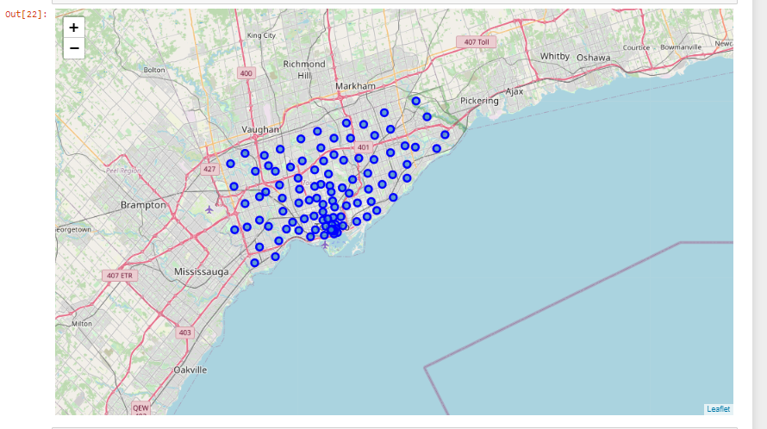

3. Clustering Approach:

To compare between multiple neighborhoods, we decided to segment and group them into Clusters. It is achieved by using K- means Clustering which is an unsupervised ML(Machine Learning) algorithm.

We have used One-Hot encoding for grouping various neighborhoods as per the amenities present.

a **one-hot** is a group of bits among which the legal combinations of values are only those with a single high (1) bit and all the others low

Using the Foursquare API we can explore various neighborhoods, their reviews, photos etc. We have certain restrictions on the number of http requests so we set the neighborhood parameter to 100 and radius parameter to 500.

**Implementation**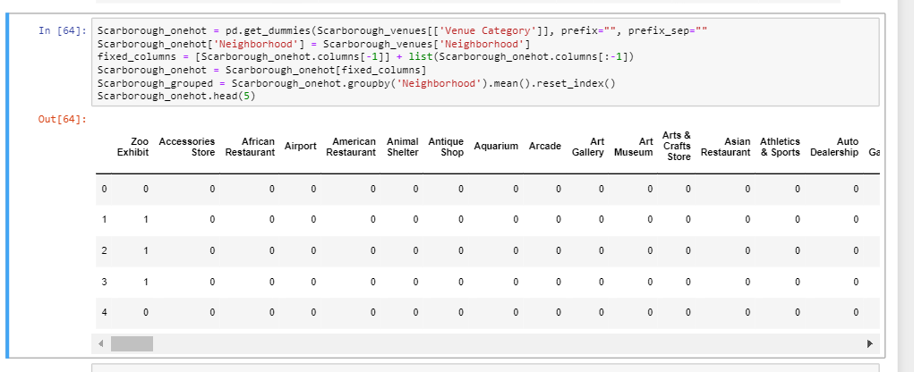

4. Results:

**Clusters in Scarborough**

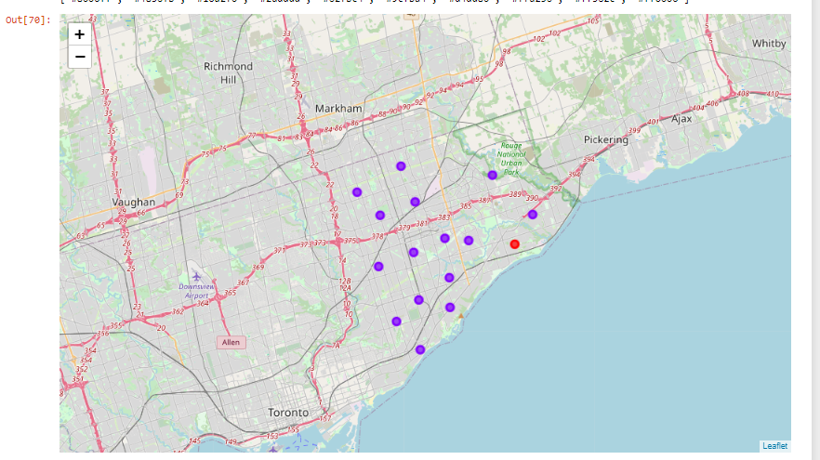

**Average House Price in** **Scarborough**

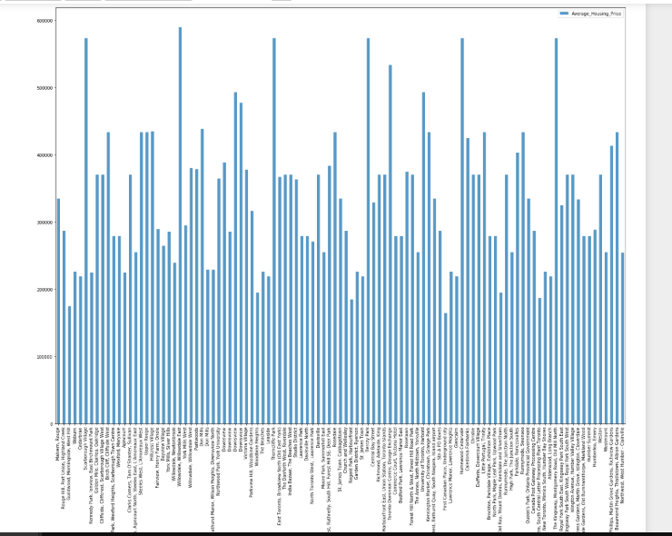

**School Rating in** **Scarborough**

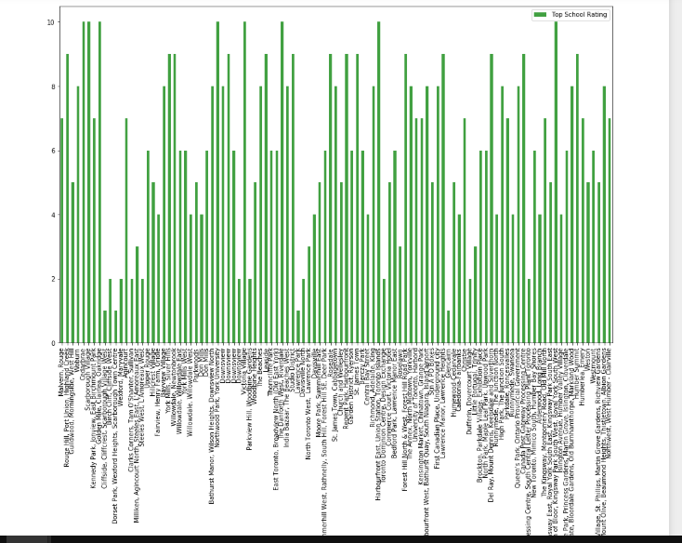

About the Location: Scarborough is a popular destination for new immigrants in Canada to reside. As a result, it is one of the most diverse and multicultural areas in the Greater Toronto Area, being home to various religious groups and places of worship. Although immigration has become a hot topic over the past few years with more governments seeking more restrictions on immigrants and refugees, the general trend of immigration into Canada has been one of on the rise.

Data Source Used: We used Foursquare Location Data as the data source.Foursquare, is an American technology company. The company's location platform is the foundation of several business and consumer products, including the Foursquare City Guide and Foursquare Swarm apps.

5. Discussion Section:

These neighbourhoods are constantly evolving, and boundaries can become blurred and disputed. Finding a good place to live could have be one of the most daunting tasks when [moving to Toronto](https://moving2canada.com/moving-to-toronto/) but not after this analysis. To live alone, a single bachelor condo may set you back around $1500-1600 a month in rent, and you can expect to have to compete with others just to get the lease. The rental market in Toronto is a competitive one, with demand continuing to outpace supply. Yorkville is one of the wealthiest parts of Toronto, though there are still some condo buildings in and around Yorkville which may prove to be affordable to the middle classes. Liberty Village is basically a gathering of high rise condos that has emerged as a little village of its own at the end of King West, mainly populated mainly by young professionals. One of the busiest and most energetic parts of Toronto, King West is for those who truly want to embrace city life. Vogue magazine placed West Queen West second in its list of the [coolest neighbourhoods in the world](https://www.vogue.com/slideshow/fifteen-coolest-street-style-neighborhoods#2) just a few years ago, and it’s got enough boutiques, vintage clothes shops, record stores, and art galleries to back that up.

6. Conclusion Section:

Completing the Capstone Project was really a great experience.

* At the very first we used the data available from Wikipedia for defining the basis for the project.
* We then used the Foursquare API acquiring all the data related to different venues and neighborhoods in the **Scarborough, Toronto.**
* **We then took help of the popular unsupervised Machine Learning algorithm k-means for clustering and separating the data into 10 different clusters.**
* **We then used the power of Folium to visualize these clusters.**